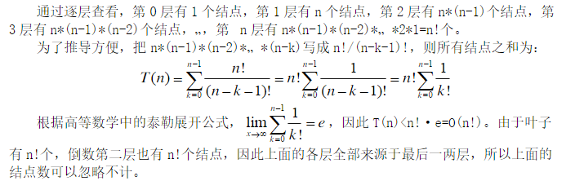
depth 0 1 node
depth 1 n nodes
depth 2 n*(n-1) nodes
depth 3 n*(n-1)*(n-2) nodes
…
depth n n! nodes
n*(n-1)*(n-2)*…*(n-k) = n!/(n-k-1)!
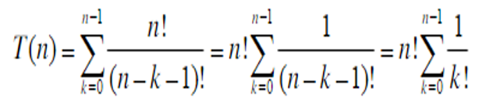
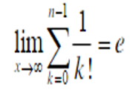
T(n)<n!*e=O(n!)
e≈2.718 Both depth n and depth n-1 have n! nodes, so the number of nodes from depth 0 to depth n-2 < n!, that is, in most cases, the number of nodes in the last two layers of a decision tree plays a decisive role.

